Modul Number: 0750362
Module Name: Database Applications

Teacher: Eman Alnaji

Part III
SQL (Single-row Functions, Views, Sequence)

DUAL Table
- Dummy table
- Consists of one column and one row
- Can be used for table reference in the FROM clause
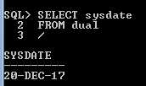
Sysdate: Returns the current date stored on your system.
Single-Row Functions
Single-row Function: returns one row of results for each record processed.
The following are some of the functions that will be discussed shortly.
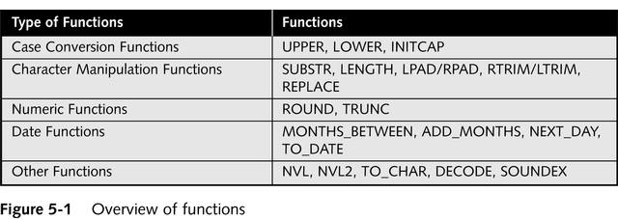
These functions can be used in a Select statement, update or insert. In Select statements, they can be used in the columns part and/or in the where part.
First: Case Conversion Functions
Alter the case of data stored in a column or character string
LOWER: Used to convert characters to lower-case letters
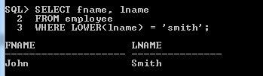
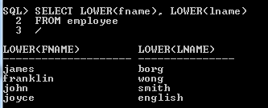

UPPER: Used to convert characters to upper-case letters
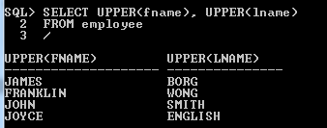
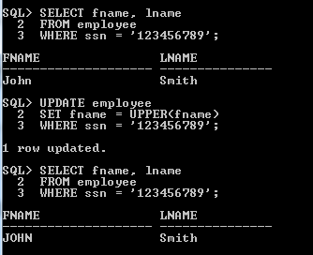
INITCAP: Used to convert characters to mixed-case
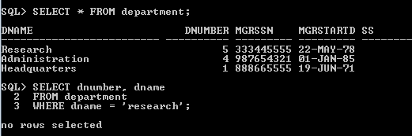
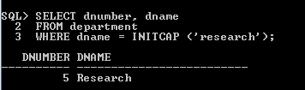

Second: Character Manipulation Functions
Manipulates data by extracting substrings, counting number of characters, replacing strings, etc.
SUBSTR: Used to return a substring, or portion of a string
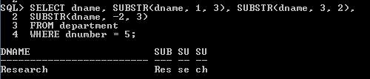
LENGTH: Used to determine the number of characters in a string
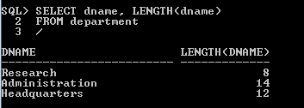
LPAD: Used to pad, or fill in, a character string to a fixed width, the filling will be in the left side of the string.
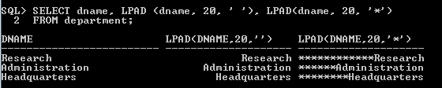
RPAD: Used to pad, or fill in, a character string to a fixed width, the filling will be in the right side of the string.
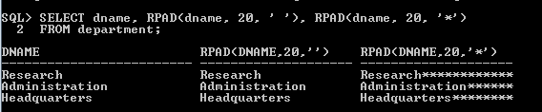

LTRIM: Used to remove a specific string of characters from the left of the string.
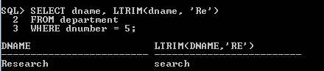
RTRIM: Used to remove a specific string of characters from the right of the string.
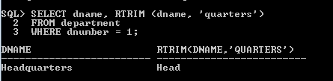
REPLACE: Substitutes a string with another specified string.
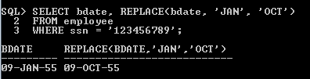
CONCAT: Used to concatenate two character strings
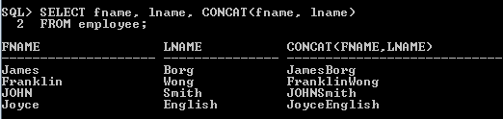
Third: Number Functions
Allows for manipulation of numeric data
ROUND: Used to round numeric columns to a stated precision
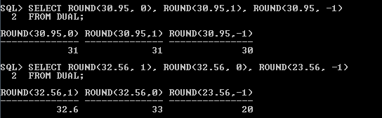
TRUNC: Used to truncate a numeric value to a specific position
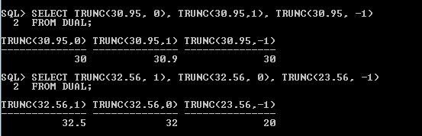

Fourth: Date Functions
MONTHS_BETWEEN: Determines the number of months between two dates
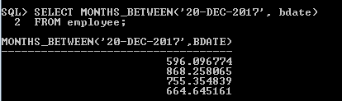
ADD_MONTHS: Adds a specified number of months to a date
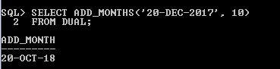
NEXT_DAY: Determines the next occurrence of a specified day of the week after a given date
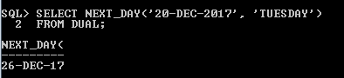
TO_DATE: Converts various date formats to the internal format (DD-MON-YYYY) used by Oracle9i
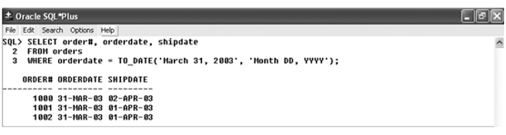

Format Model Elements – Dates
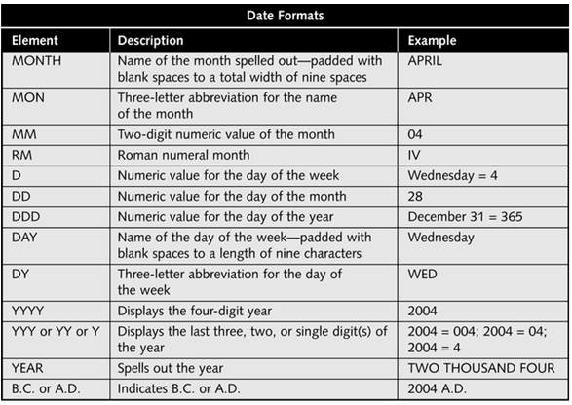
Fifth: Other Functions
NVL: Substitutes a value for a NULL value
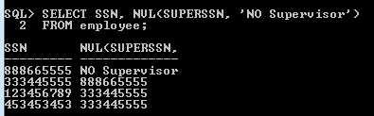

NVL2: Allows different actions based on whether a value is NULL
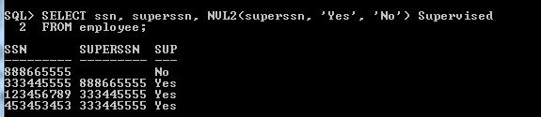
TO_CHAR: Converts dates and numbers to a formatted character string
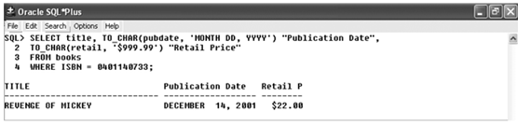
Format Model Elements – Time and Number
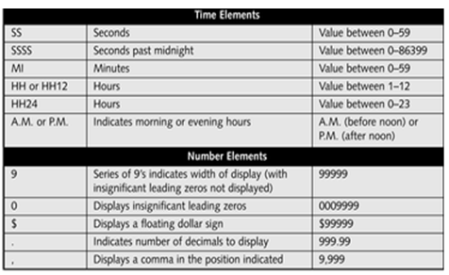
DECODE: Determines action based upon values in a list
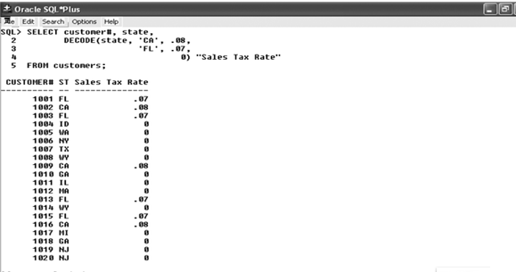
Nesting Functions
- One function is used as an argument inside another function
- Must include all arguments for each function
- Inner function is resolved first, then outer function
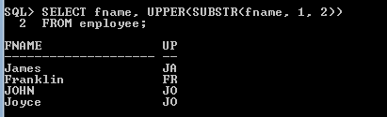

Views
- A view is a virtual table based on the result-set of a SELECT statement.
- A view contains rows and columns, just like a real table. The fields in a view are fields from one or more real tables in the database.
- You can add SQL functions, WHERE, and JOIN statements to a view and present the data as if the data were coming from one single table.
Specification of Views
- a table (view) name
- a possible list of attribute names (for example, when arithmetic operations are specified or when we want the names to be different from the attributes in the base relations)
- a query to specify the table contents
Example on Views:
- Specify a different WORKS_ON table
CREATE VIEW WORKS_ON_NEW AS
SELECT FNAME, LNAME, PNAME, HOURS
FROM EMPLOYEE, PROJECT, WORKS_ON
WHERE SSN = ESSN
AND PNO = PNUMBER;
- We can specify SQL queries on a newly create table (view):
SELECT FNAME, LNAME
FROM WORKS_ON_NEW
WHERE PNAME=‘Seena’;

- When no longer needed, a view can be dropped:
DROP VIEW WORKS_ON_NEW;
If the view definition needs to change, a CREATE OR REPLACE VIEW command is used.
CREATE OR REPLACE VIEW WORKS_ON_NEW AS
SELECT FNAME, LNAME, PNAME, HOURS, PNO
FROM EMPLOYEE, PROJECT, WORKS_ON
WHERE SSN = ESSN
AND PNO = PNUMBER;
Advantages of Views:
- To restrict data access
- To make complex queries easy
- To provide data independence
- To present different views of the same data
- You can retrieve data from a view as from a table.

Sequences
- Automatically generates unique numbers
- Is typically used to create a primary key
Create Sequence Syntax:
CREATE SEQUENCE sequence_name
[INCREMENT BY n]
[START WITH n]
[{MAXVALUE n | NOMAXVALUE}]
[{MINVALUE n | NOMINVALUE}];
Example of Creating a Sequence:
CREATE SEQUENCE deptid_seq
INCREMENT BY 10
START WITH 5
MAXVALUE 9999;

- NEXTVAL returns the next available sequence
value. It returns a unique value every time it is
referenced, even for different users
- CURRVAL obtains the current sequence value.
NEXTVAL must be issued for that sequence before
CURRVAL contains a value

Using a sequence:
INSERT INTO dept(deptno, dname, loc)
VALUES (deptid_seq.NEXTVAL,'Support', ' HONG KONG' );
View the Current Value:
SELECT deptid_seq.CURRVAL
FROM dual;
Removing a Sequence:
DROP SEQUENCE deptid_seq;

